**Supplementary Materials**

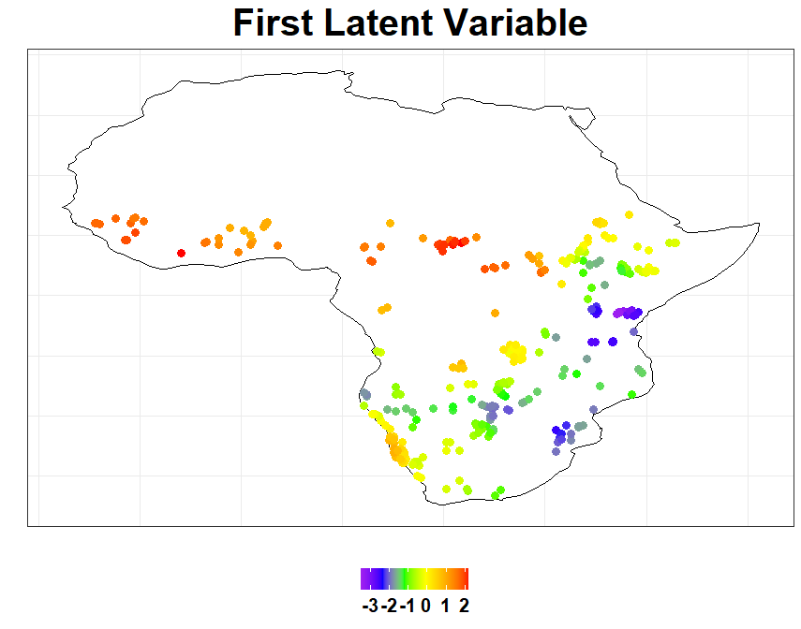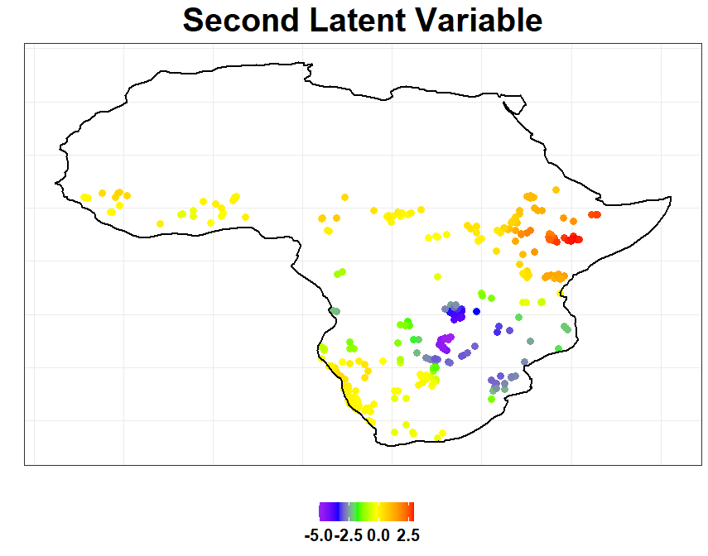

A

B

Figure S1. The raw site loadings values of the first (A, upper) and second (B, lower) latent variable from the Open Habitats model for all points in the model.

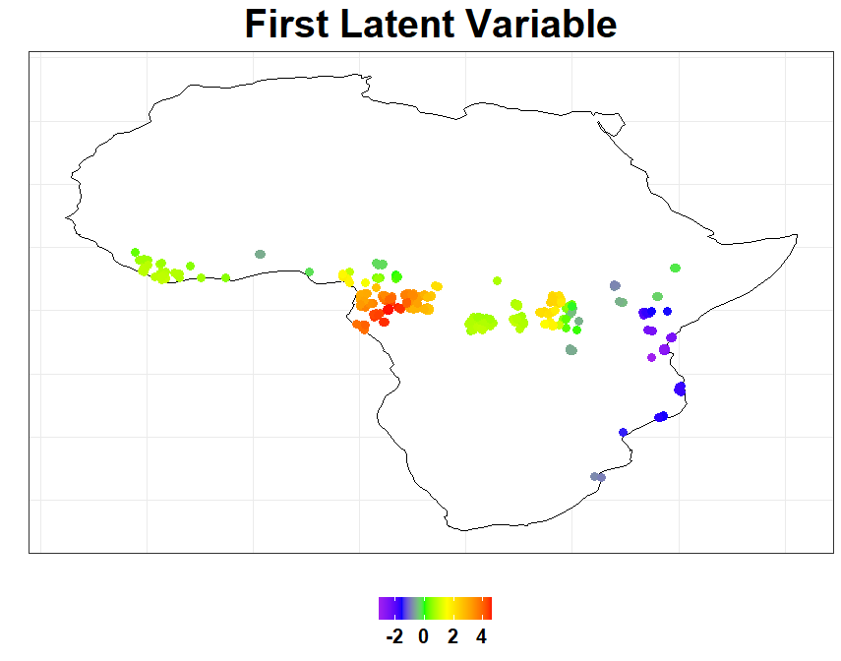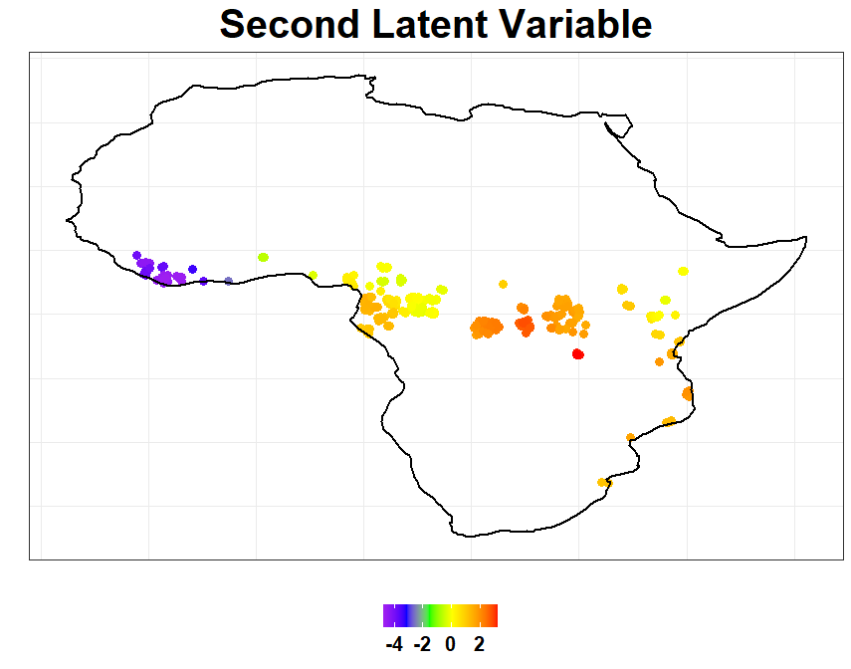

A

B

Figure S2. The raw site loadings values of the first (A, upper) and second (B, lower) latent variable from the Tropical Forests model for all points in the model.